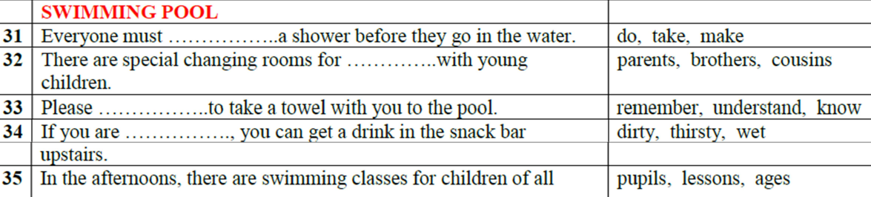

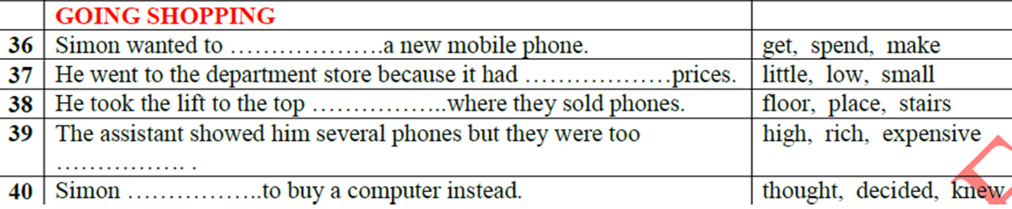

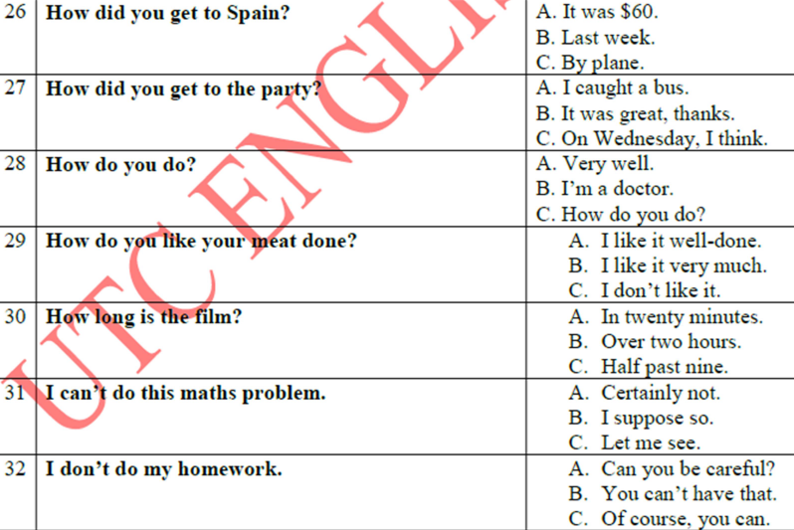



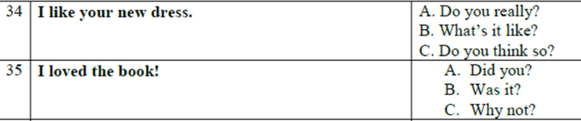

PART 3_2

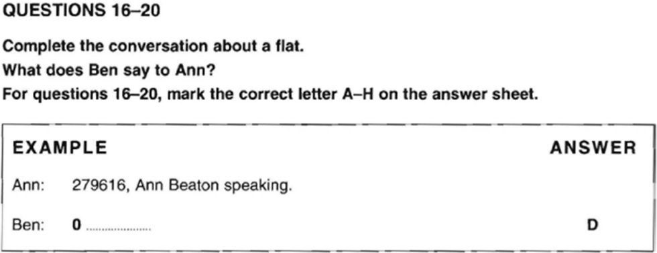

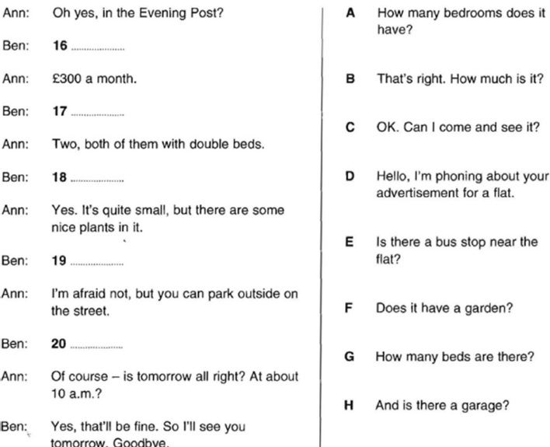

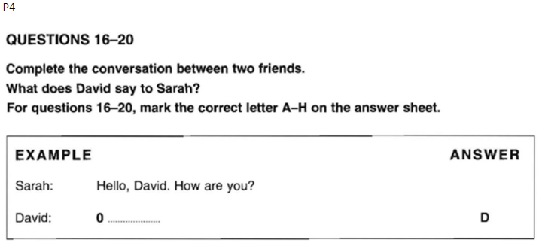

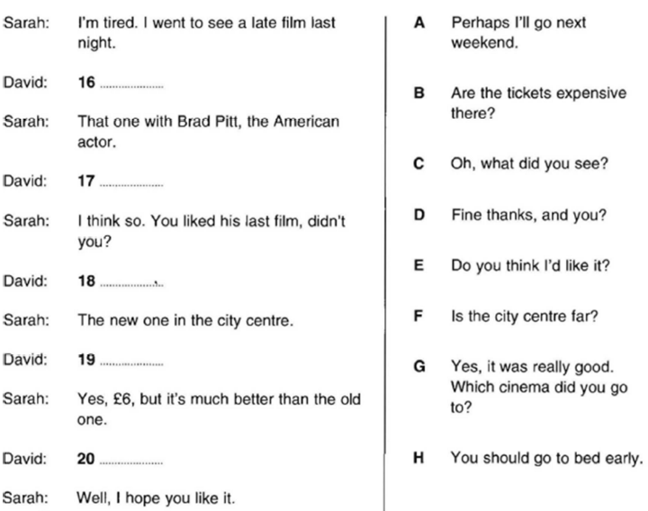

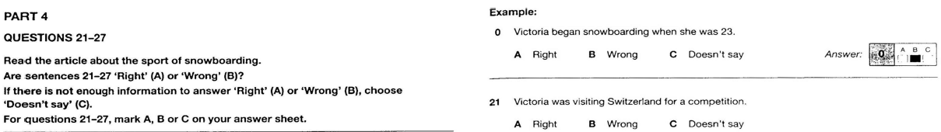

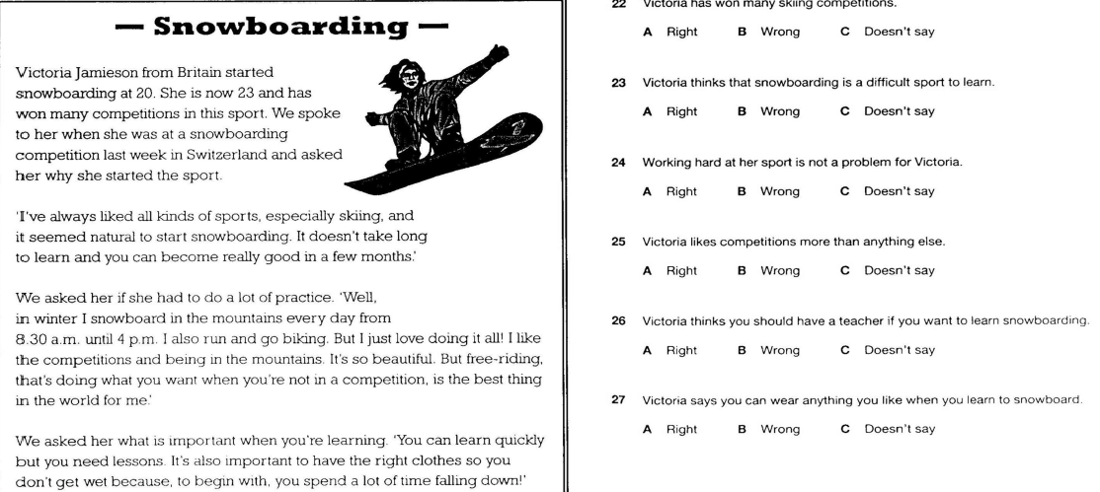

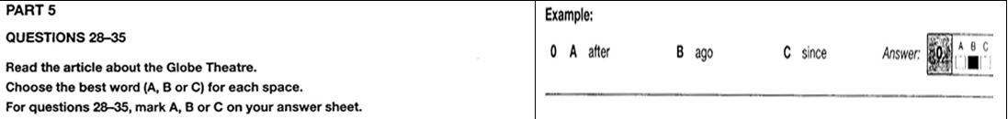

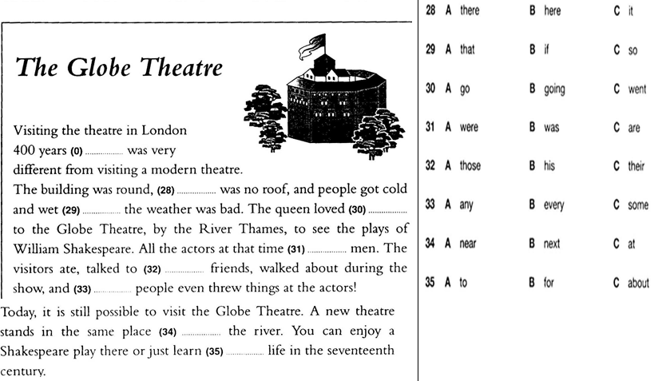

PART 6:

1. If it’s your birthday, your guests may give you this p _ _ _ _ _ _
2. You need this to put your drink in g _ _ _ _
3. You hope these people will come to your party f _ _ _ _ _ _
4. This is a large group of trees f _ _ _ _ _
5. You may find snow on the top of this at all times of the year m _ _ _ _ _ _ _
6. The farmer puts animals or plants here f _ _ _ _
7. People have to cross water to get to this i _ _ _ _ _
8. The water in this starts in the hills and runs to the sea r _ _ _ _
9. Engineers build this to take things in boats from one place to another c _ _ _ _
10. When your friends go on holiday, they send you this p _ _ _ _ _ _ _
11. If you don’t understand a word, you can look in this d _ _ _ _ _ _ _ _ _
12. You can buy this every week and read about many interesting subjects in it m _ _ _ _ _ _ _
13. If you write about your daily life in this, you may not want anyone to read it d _ _ _ _
14. You write this for your mother when you answer the phone for her m _ _ _ _ _ _
15. People buy this every morning to read about what has happened in the world n _ _ _ _ _ _ _ _
16. If you do not wear a coat outside in the snow, you feel like this c _ _ _
17. People feel like this when they get good news h _ _ _ _
18. This is often on a shirt and you can put pens in it p _ _ _ _ _
19. People wear this in the winter when they go outside c _ _ _
20. This is the top part of a suit for me and women j _ _ _ _ _

PART 7:

**Practice 10:**



**Practice 11:**



Part 9:

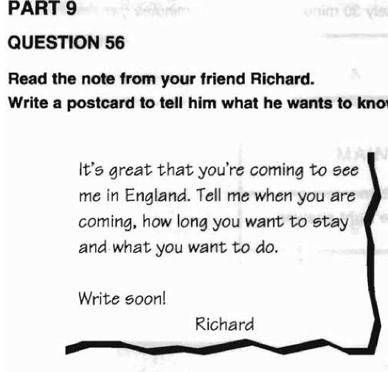

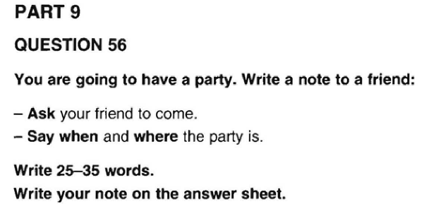

TEST 4:

